**Assignment: 5**

**Program for create random sentence from given data object, verb and adverb.**

**C++**

#include <iostream>

#include <string.h>

#include <stdlib.h>

#include <ctype.h>

#include <time.h>

using namespace std;

char *object[] = { "waves", "big yellow flowers", "slugs", "any" };

char *verb[] = { "sigh", "portend like", "die"};

char *adverb[] = { "warily", "grumpily",""};

main()

{

const int words = 3;

const int sentences = 3; // Number of sentences to generate

string space = " "; // Space string

srand(time(NULL));

string sentence = "";

for (int i = 0; i < sentences; i++)

{

sentence = space + object[rand()%words] + space + verb[rand()%words] + space+ adverb[rand()%words];

cout<<"The"<<sentence<<" tonight."<<endl;

sentence = "";

}

}

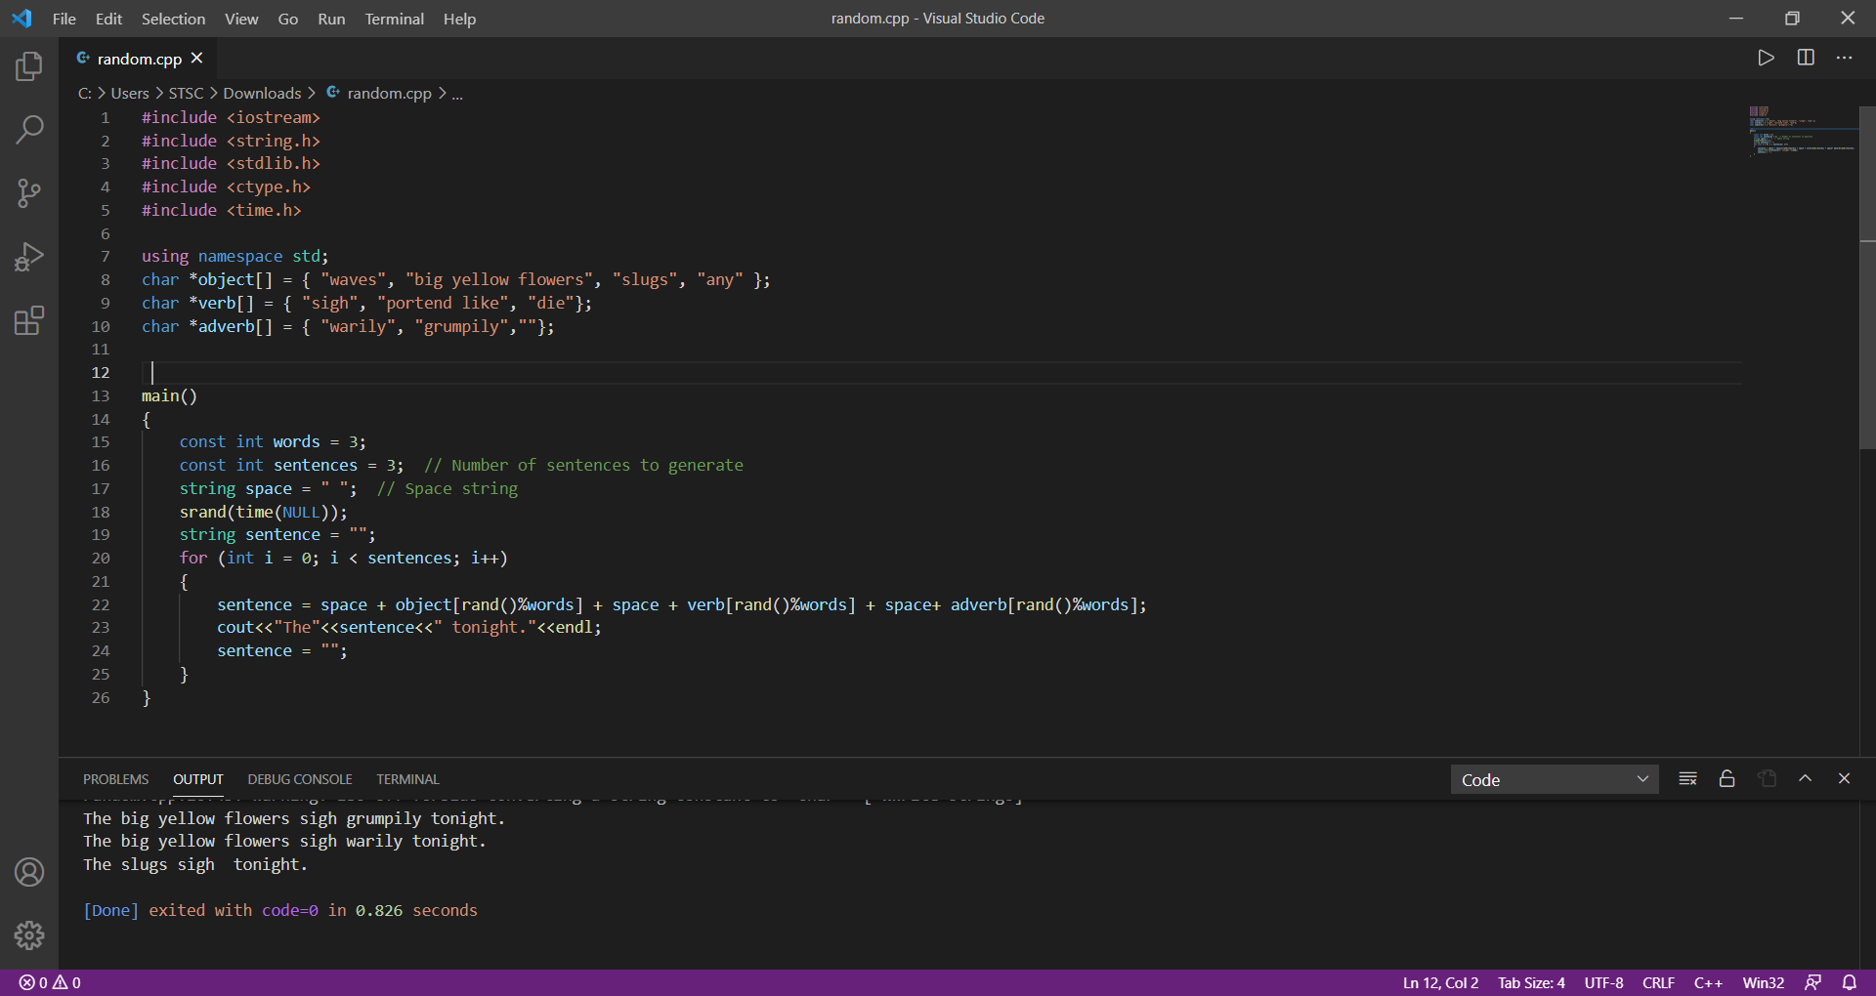

**JAVA**

import java.util.Random;

public class random{

final static String space = " ";

final static String period = ".";

static Random r = new Random();

public static void main( String args[] ){

String object[] = { "waves", "big yellow flowers", "slugs"};

String adverb[] = { "warily", "grumpily", "a"};

String verb[] = { "sigh", "portend like ", "die"};

String preposition[] = { "to", "from", "over", "under", "on" };

int sentences = 3;

String sentence;

sentence = object[rand()];

char c = sentence.charAt(0);

for(int i =0;i<sentences;i++)

{

sentence = (space + object[rand()] + space + verb[rand()] + space+ adverb[rand()]);

System.out.println("The"+sentence+ " tonight.");

sentence = "";

}

}

static int rand(){

int temp = r.nextInt() % 3;

if ( temp < 0 )

temp += 3;

return temp;

}

}

